Practical-15
Final Integration, Testing, Documentation, GitHub Submission, and Local Deployment
Theory :
- Are all pages properly linked and navigable?
Answer: Yes, all pages are properly linked, and users can navigate between them easily.
2. Are sessions, roles, validations, and database operations working end-to-end?
Answer: Yes, sessions, role-based access, validations, and database operations are working correctly.
3. Are security and accessibility checklists completed?
Answer: Yes, security measures and accessibility requirements have been checked and implemented.
4. Is project documentation sufficient for installation and testing?
Answer: Yes, the documentation includes installation steps, configuration details, and testing instructions.
5. Is the project repository clean and properly committed? Answer: Yes, the repository is organized, unnecessary files are removed, and changes are properly committed using Git.

Result:

1)admin rights management
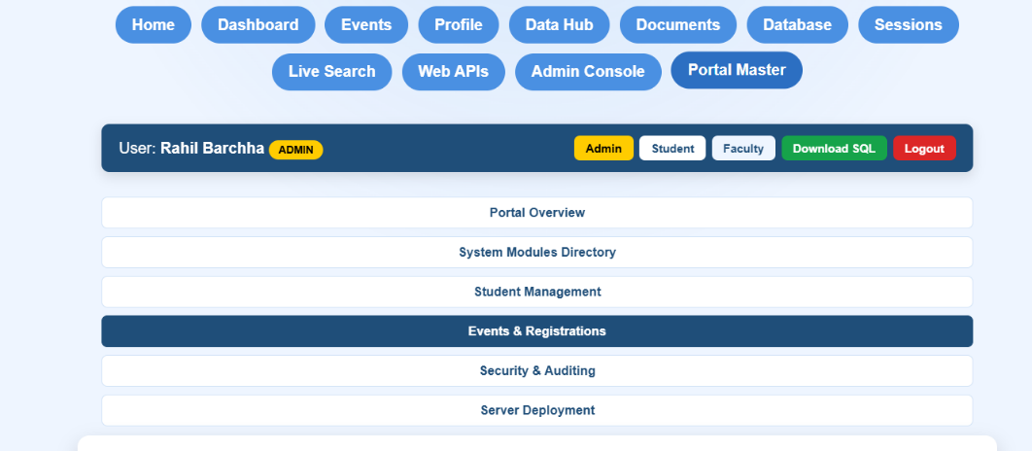
2) data analytics for events and summary
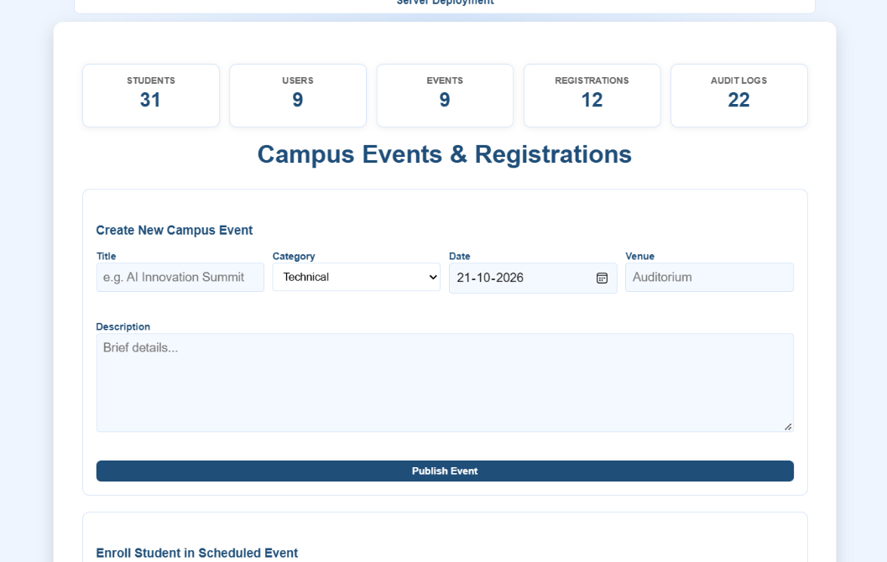

3)student account management via admin account
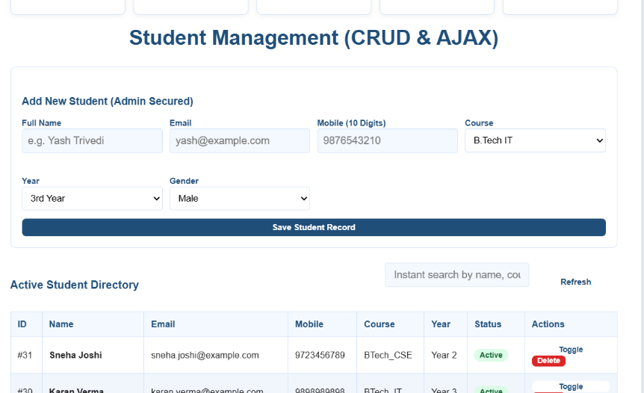

4)information for every page
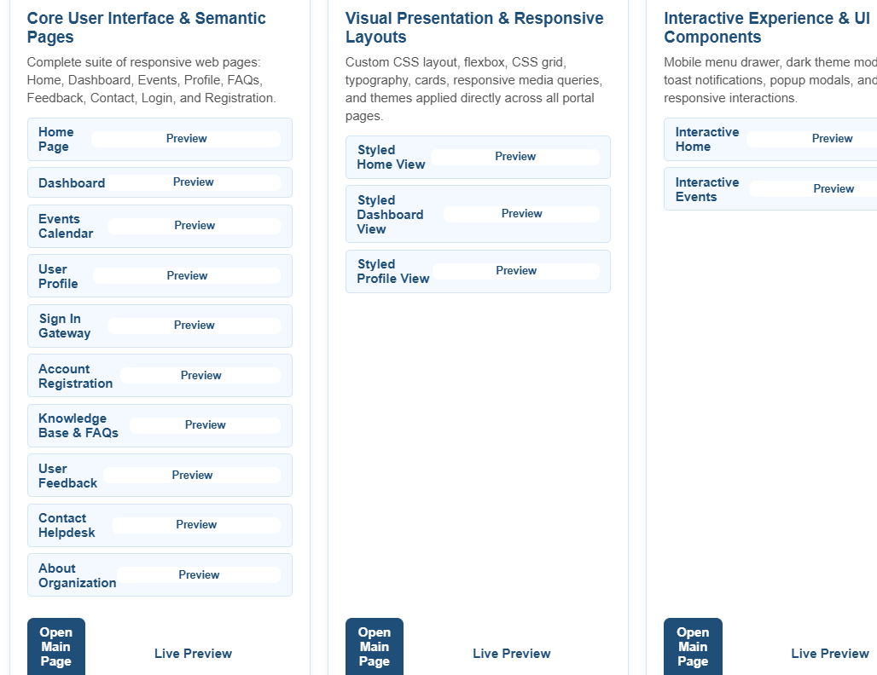

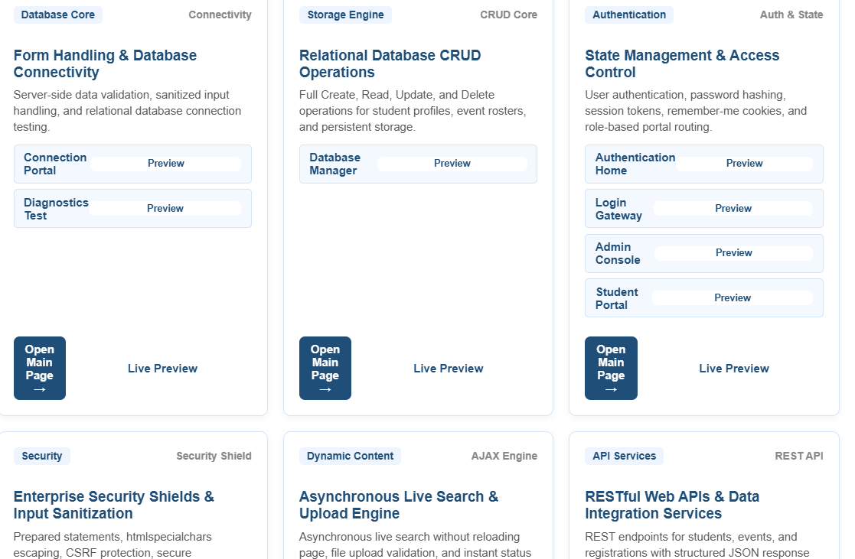

Git Hub Repository Link:
https://github.com/RahilBarchha/student-hub-.git
Challenges Faced: Integrating all modules into the StudentHub portal, fixing navigation and responsiveness issues, debugging authentication and database operations, testing security and AJAX functionality, configuring XAMPP/Apache, and preparing GitHub documentation.

Learning Outcome: Learned to integrate, test, and deploy a complete full-stack web application, manage authentication and database operations, implement security and accessibility checks, use GitHub for version control, and prepare project documentation.

